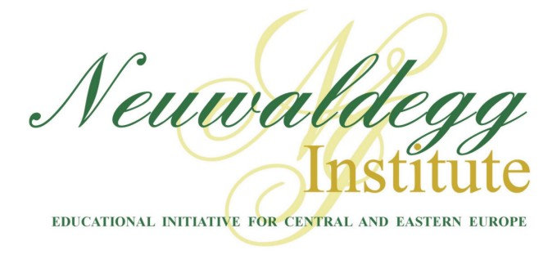

Vienna, April 19, 2005

Dear Director of the International Relations Office,

In the coming months the Neuwaldegg Institute in Vienna, Austria will continue its schedule of conferences for select groups of students from Central and Eastern Europe. By this letter I would like to inform you about two upcoming conferences. The first, from June 27th – 30th, 2005, is entitled “Psychology for the 21st Century”. It is open to graduate students in psychology only. The second conference, which will take place from August 8th – 13th, 2005, is our annual Neuwaldegg Seminar. Applicants to this seminar are welcomed from various faculties, especially law, politics, business, and medicine. We would be happy to consider students from your university for a full scholarship to these events.

The Neuwaldegg Institute is a division of the Educational Initiative for Central and Eastern Europe (EICEE), a non-profit, non-denominational academic organization headquartered in Vienna, Austria, with offices in Washington, New York and Prague. We promote a wide range of educational and cultural programs, which foster reflection upon ideas fundamental to the construction of free and fair societies and stimulate the development of civic values and social institutions in formerly Soviet nations.

“Psychology for the 21st Century” will be led by Dr. Paul Vitz, a Professor of Psychology Emeritus at the New York University, and a Professor of Psychology/Senior Scholar at the Institute for Psychological Sciences in Arlington, Virginia. Since getting his doctorate in experimental psychology at Stanford University, he has done extensive research in personality theory, moral development and psychology and art. He is the author of several books and numerous articles. The subject of this conference will be the analysis of several new trends in psychology including new approaches to positive psychology and personalism, as well as the role of forgiveness in psychotherapy. Please note that completed applications for the psychology conference must be received no later than May 13th.

This year’s Neuwaldegg Seminar will be similar in format to last year. A team of professors with expertise in different aspects of philosophy will present an array of issues to stimulate reflection on the constitutive elements of stable democracies and genuine freedom. Participants come from a wide range of academic disciplines and nations ensuring fruitful discussion on how these principles are applied in contemporary circumstances. There is ample opportunity for interaction of various kinds with the professors and visiting speakers throughout the week. Applications for this conference must be received by June 3rd.

This letter entitles you to invite those students, who best represent the achievements of their respective departments, to apply for a full scholarship. In the past, those with teaching experience have also participated and appreciated the high academic level. For those who are accepted, the Neuwaldegg Institute will cover expenses related to food, lodging and tuition.

Applicants must have the recommendation of their dean and a command of the English language sufficient to understand and participate in discussions. Please find the application enclosed. All inquiries and applications should be sent to conference@neuwaldegg.org.

Sincerely,

Mattias Caro
Director of Admissions
Neuwaldegg Institute
Telephone: +43-1-485-9775
Fax: +43-1-485-9775-20
Vienna, April 19, 2005

RE: APPLICATION FOR PSYCHOLOGY CONFERENCE

Dear Student,

Thank you for your interest in the conference, entitled “Psychology for the 21st Century,” which will take place from June 27th – 30th, 2005 at our academic centre in Vienna, Austria. To be considered for a full scholarship your application and accompanying materials must be received by May 13th, 2005. The preferred method of submissions is via email, although you may fax them if that is more convenient. Decisions regarding acceptance and notification will take place by May 20th.

Type or print the required information on the application form. All documentation must be written in English. The application itself must be completed by the student as an indication of his/her level of proficiency in the English language.

Please note that in addition to the attached application form, the following items must be submitted:

- A curriculum vitae (CV) including educational background and work experience. Note: no more than one page.

- Essay of approximately 250 words: describe the role specific to practitioners of psychology in meeting the challenges presented to your society during its transition in the post-Soviet era.

There is no fee for application or registration. The scholarship includes food, lodging and tuition. Ordinarily, travel expenses are covered by the student or his/her academic institution.

For further information on admissions please contact:

Mattias Caro
Director of Admissions
Neuwaldegg Institute
Telephone: + 43-1-485-9775
Fax: + 43-1-485-9775-20
Email: conference@neuwaldegg.org

Vienna, April 19, 2005

RE: APPLICATION FOR NEUWALDEGG SEMINAR

Dear Student,

Thank you for your interest in the Neuwaldegg Summer Seminar, which will take place from August 8th – 13th, 2005 at our academic centre in Vienna, Austria. To be considered for a full scholarship your application and accompanying materials must be received by June 3rd, 2005. The preferred method of submissions is via email, although you may fax them if that is more convenient. Decisions regarding acceptance and notification will take place by June 10th.

Type or print the required information on the application form. All documentation must be written in English. The application itself must be completed by the student as an indication of his/her level of proficiency in the English language.

Please note that in addition to the attached application form, the following items must be submitted:

- A curriculum vitae (CV) including educational background and work experience. Note: no more than one page.

- Essay of approximately 250 words: choose a philosopher whose thought, in your opinion, would be most helpful to civic leaders in meeting the challenges presented to your society during its transition in the post-Soviet era, and defend your choice.

There is no fee for application or registration. The scholarship includes food, lodging and tuition. Ordinarily, travel expenses are covered by the student or his/her academic institution.

For further information on admissions please contact:

Mattias Caro
Director of Admissions
Neuwaldegg Institute
Telephone: + 43-1-485-9775
Fax: + 43-1-485-9775-20
Email: conference@neuwaldegg.org

The Neuwaldegg Institute
Conference on Psychology, June 2005

Applications may be submitted by email, fax or express mail. To insure consideration, applications must be received by May 13th, 2005. There is no fee for application or registration.

Personal Information

Family name (Latin alphabet) ____________________________ First name ___________________________

Date of birth _____ (day) ______ (month) _________ (year) Age ________

Place of birth ___________ (city) ________________ (country)
Nationality __________________
Gender  Male  Female

Passport Information

Country of citizenship ___________________
Passport number _____________________
Place of Issue ______________ Date of Issue ____________________ Valid until ___________________

Mailing address (current in late may and early june)

Street address _______________________________________________________________________________________
City _______________ Postal code _____________ Country ___________________
Phone (with country code) _(_______)_________________ Fax _________(______)_______________________

Email _________________@_________________________

education

Name of University ______________________________________
Specialization/faculty ____________________ Degrees attained _______________________
Languages (in addition to English in which you are either fluent or conversational) ____________________________________
Career plans after graduation (Please be brief)

Nominating/Recommending Professor__________________________ email____________________________________

The Neuwaldegg Institute
Neuwaldegg Seminar, August 2005

Applications may be submitted by email, fax or express mail. To insure consideration, applications must be received by June 3rd, 2005. There is no fee for application or registration.

Personal Information

Family name (Latin alphabet) ____________________________ First name ___________________________

Date of birth _____ (day) ______ (month) _________ (year) Age ________

Place of birth ___________ (city) ________________ (country)
Nationality __________________
Gender  Male  Female

Passport Information

Country of citizenship ___________________
Passport number _____________________
Place of Issue ______________ Date of Issue ____________________ Valid until ___________________

Mailing address (current in late june and early july)

Street address _______________________________________________________________________________________
City _______________ Postal code _____________ Country ___________________
Phone (with country code) _(_______)_________________ Fax _________(______)_______________________

Email _________________@_________________________

education

Name of University ______________________________________
Specialization/faculty ____________________ Degrees attained _______________________
Languages (in addition to English in which you are either fluent or conversational) ____________________________________
Career plans after graduation (Please be brief)

Nominating/Recommending Professor__________________________ email____________________________________

The Neuwaldegg Institute
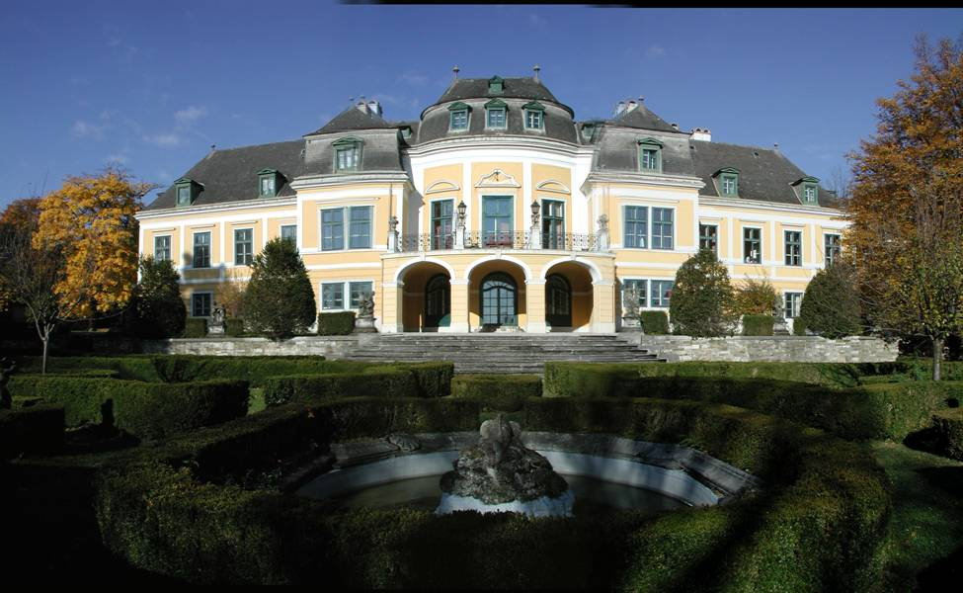

Schloss Neuwaldegg – the headquarters and
conference centre of the Neuwaldegg Institute

Located in Vienna, Austria, a traditional meeting point for East and West, and housed in the baroque splendour of newly-renovated Schloss Neuwaldegg, the Neuwaldegg Institute is the primary centre for the conferences and seminars of the Educational Initiative for Central and Eastern Europe (EICEE). Under the leadership of the foundation’s President, Baron Damian von Stauffenberg, the Neuwaldegg Institute has welcomed hundreds of academics and professionals for intensive discussions in a variety of fields relevant to the development of free, just and ethical societies in Central and Eastern Europe (CEE).

EICEE’s Neuwaldegg Institute enjoys the support of its distinguished Board of Advisors, which includes towering figures of academic, cultural, and public life: Dr. Wladyslaw Bartoszewski, the former Minister of Foreign Affairs, Poland; Jan Carnogursky, lawyer, anti-communist dissident, and former Prime Minister of Slovakia; as well as Vaclav Havel, anti-communist dissident and former President of Czechoslovakia and Czech Republic, and his wife, Dagmar Havel. Other members of the board are Cardinal Christoph Schönborn, the Archbishop of Vienna; Sonia Fares of Lebanon; and Frank Shakespeare, a former president of CBS Television Service and U.S. Ambassador to Portugal and the Holy See.

The Neuwaldegg Institute’s conferences typically address issues pertaining to politics, ethics, law, history and culture. Questions examined include the role of the state in a free and democratic society, the rights and responsibilities of the individual citizen, the foundations and function of law, the relationships between freedom, morality and economic prosperity, contemporary questions of ethics, as well as regional issues tied to history and culture. Participants at such gatherings come primarily from CEE, while expert speakers are invited from across Europe, the USA, and from further afield. In this way a forum is created for dialogue among the people of CEE and for the strengthening of ties between East and West.

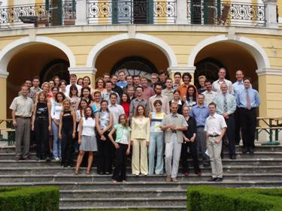
Most Recent Conferences:

1. The Neuwaldegg Seminar (August 15-22, 2004)
The Neuwaldegg Seminar consisted of four intensive courses led by distinguished professors form the USA: Dr. John and Matthew Cuddeback, Dr. Gavin Colvert, and Dr. Daniel McInerny. Students from a variety of academic disciplines were nominated by their department heads. The professors raised and examined anthropological, epistemological, and ethical topics of relevance not only to philosophers but to political scientists, business students, and lawyers. At evening seminars and even late into the night, students exchanged ideas and contributed the perspective of their particular profession and country of origin. Indeed, the 60 participants came from more than a dozen countries of Central and Eastern Europe.

2. Christian Perspectives and Free Society (September 30 – October 2, 2004 )
This conference was co-sponsored by the Civic Institute in Prague, an affiliate of the EICEE. It was the first time that this popular conference was offered in Vienna. This allowed the participation of students from Belarus, Poland, Russia, Slovakia, and the Ukraine, as well as from the Czech Republic.

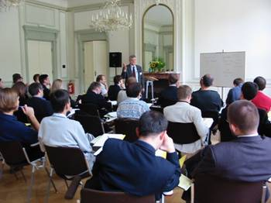
The faculty consisted of two guest speakers from the USA, Dr. Harry Veryser and Dr. Michael Foley, in addition to the Civic Institute’s own fellows: Roman Joch, Michaela Freiova, and Michael Semin.

Some of the topics examined were:
- Classical Political Thought and its Relevance for Today
- Problems with Liberalism and Conservativism
- Principles of Social Philosophy
- State and Subsidiarity

3. Human Dignity and the Failure of Communism (November 5-7, 2004)
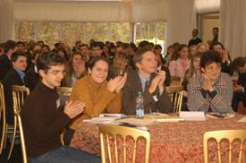
For this event more than 150 talented students from over 35 countries and five continents received scholarships. The Neuwaldegg Institute was also honoured to welcome many political leaders, university teachers, diplomats, and other VIP’s from the whole of CEE.

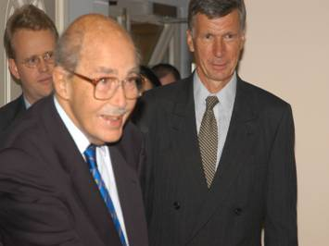
Towering figures such as President Vaclav Havel, H.I.H. Otto von Habsburg, Dr. Bartoszewski, Dr. Mart Laar, and Ambassador Lipowicz delivered a message of hope and realism. They called for the post-Soviet generation to be willing to make great sacrifices to promote and foster the good already achieved through so much sacrifices by the generation that resisted communist oppression for decades. The question of which path to take after Communism was explored by some of the most prominent figures in recent CEE history, and the hope that the new generation of academics, professionals and students would continue to forge free nations was kindled.
H.I.H Archduke Otto von Habsburg with the president of EICEE Baron Damian von Stauffenberg

4. The Rule of Law and Free Society (November 24-28, 2004)
For this conference we gathered 80 students and academics, mostly lawyers and advanced law students from 13 countries. Lectures were delivered by a renowned teacher from the University of Tulsa, Oklahoma USA, Prof. Russell Hittinger.
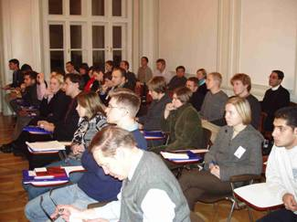
Professor Hittinger led the participants through the history of legal philosophy, touching the problems of the definition of law, its role and essential characteristics. In comparing the notion of legal positivism with the concept of natural law, he not only considered the theoretical aspects of the question, but analysed several particular bills and famous US Supreme Court decisions on a practical level.

